TC-DVA-003
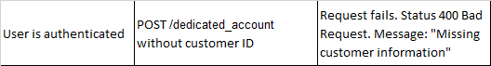
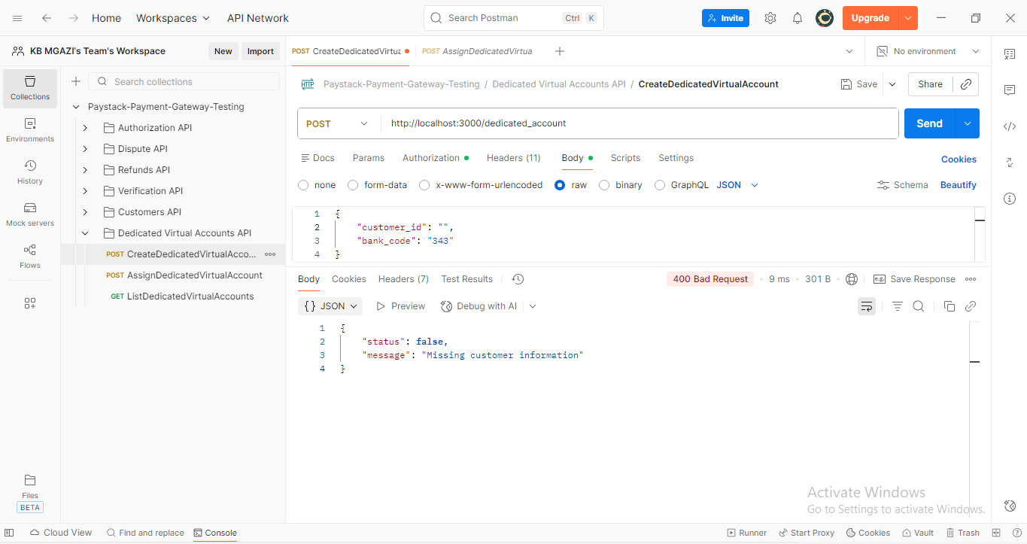
Request:
{
"customer_id": "",
"bank_code": "343"
}

Response:
{
"status": false,
"message": "Missing customer information"
}

